Auto scaling groups

Load balancer
Simply under EC2 select target groups and add 2 or more targets:
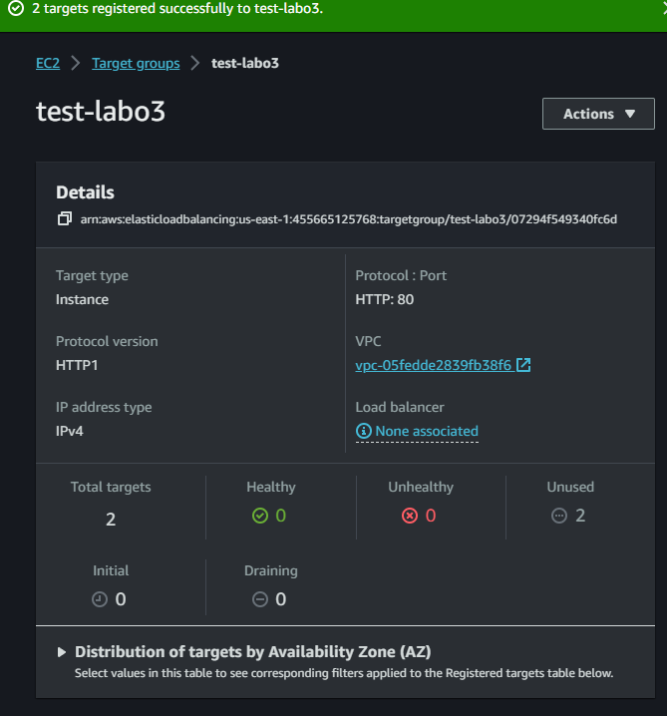
Create a new load balancer under EC2 and add test-labo3 as target-group.
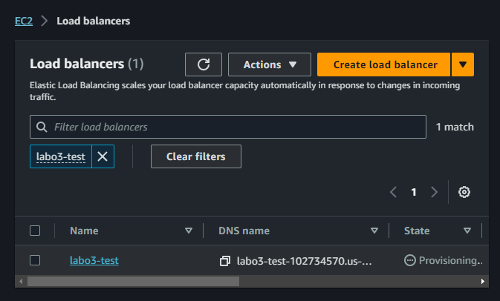
When the loading is done, you should be able to see a lodad balancing between 2 EC2 instances. (for example 2 nginx instances)

Auto Scaling group
Create new AMI with nginx installed on a Ubuntu machine.
Create simple auto scaling group based on template with the newly created AMI:
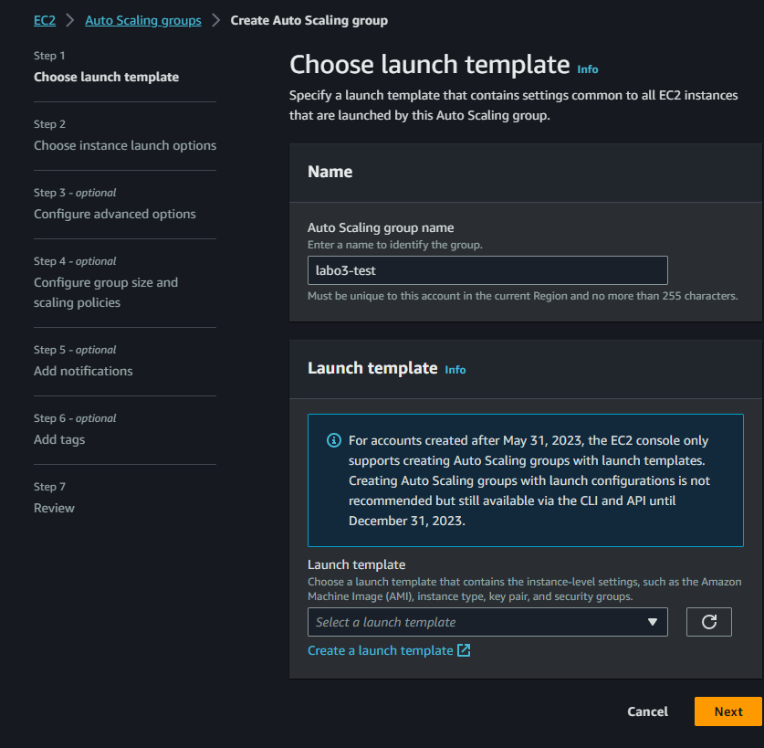
Add the load balancer:
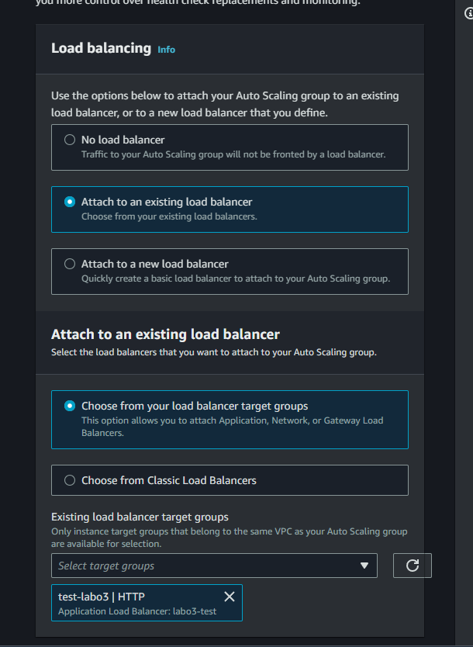
There will now be new instance created automatically when the old ones get heavy usage.

Creating a simple windows server
Just launch the standard template.
You can remote desktop into the windows server by following the instructions on the AWS console.
From the windows server you can ping/connect to the servers throught the private ip address instead of the public one.
(note: windows server will be really slow because we are using the micro free tier subscription)

Lambda

Hello World
Go into the lambda console
Create a function
Use a blueprint and select the hello world python blueprint
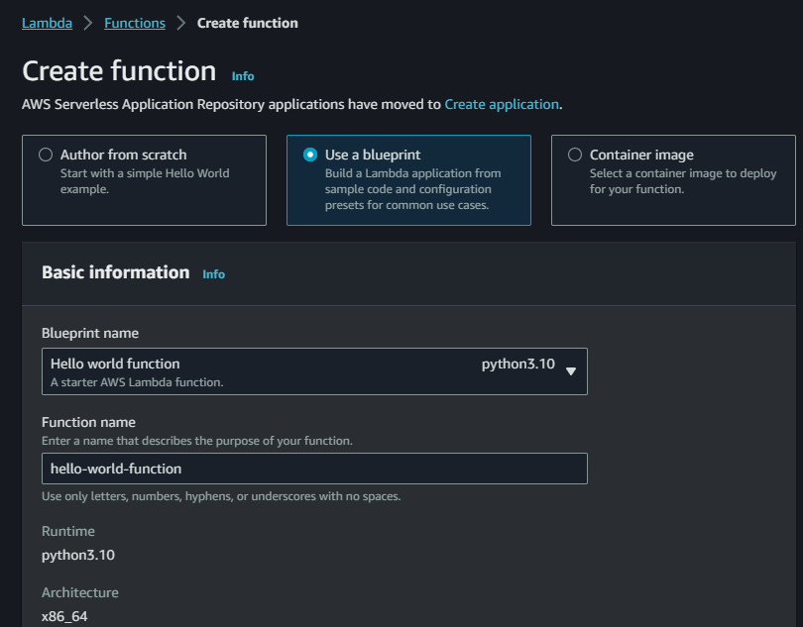
Configure a test event:
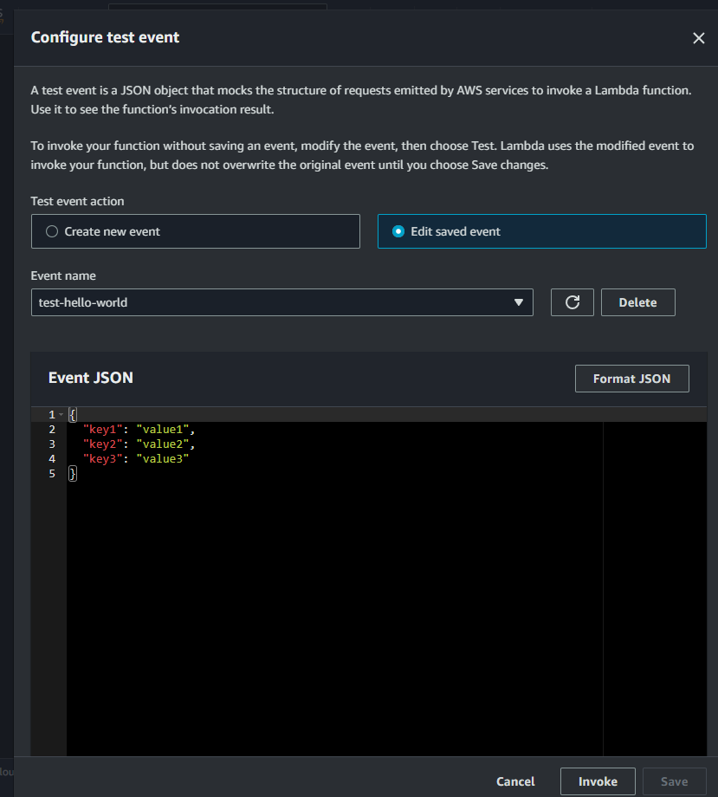
Run test function:
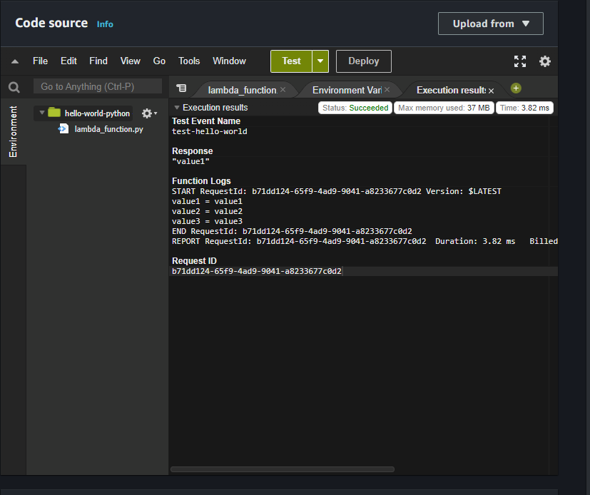
Add an api gateway:
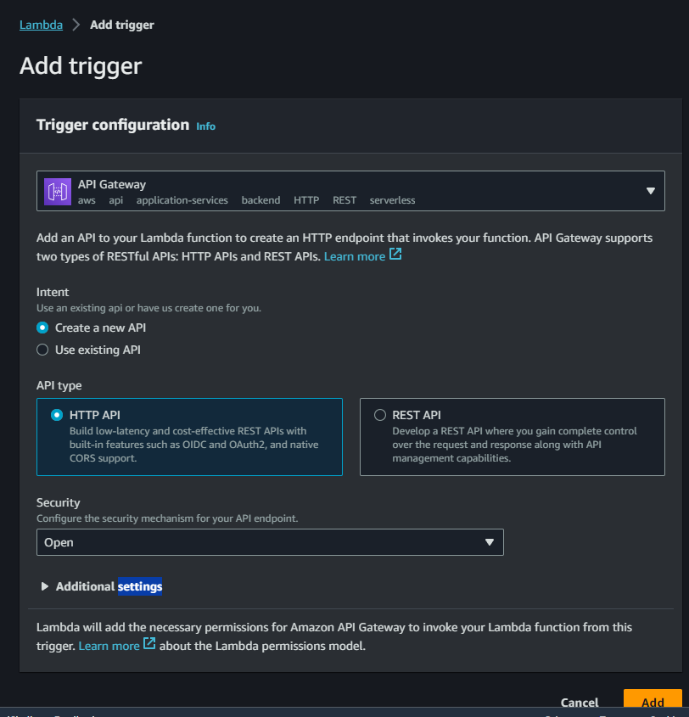
update the code this and deploy it:
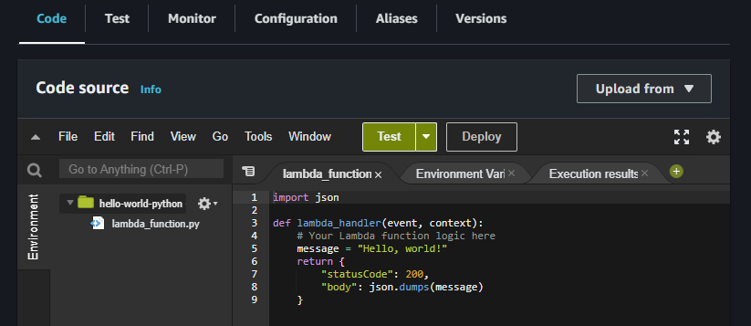

Get name
Change the code to this and deploy it:
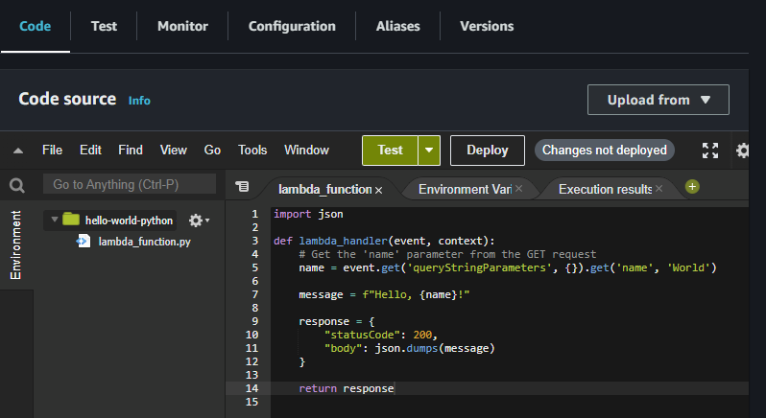
change the url request to <your-url>/hello?name=Pieter

S3 bucket update python
Update the python code:
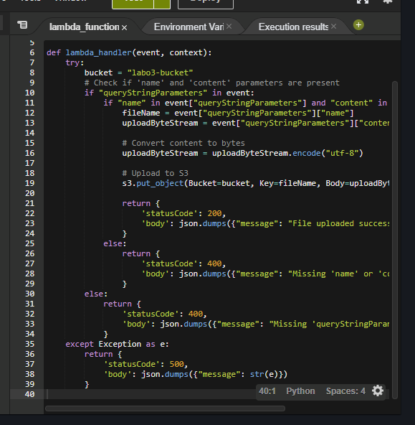
Add policy to the bucket to allow it without authentication:

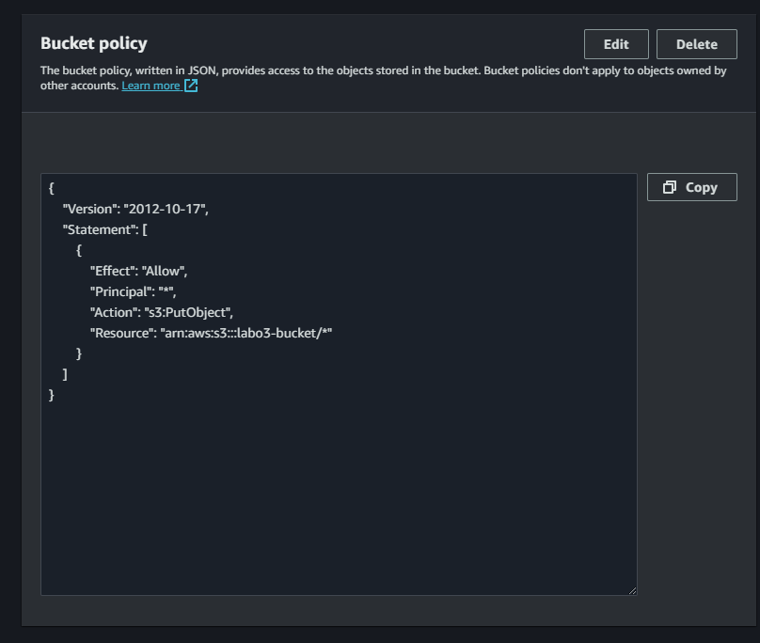
IP address:
Update the lambda code to pass an ip to the bucket.
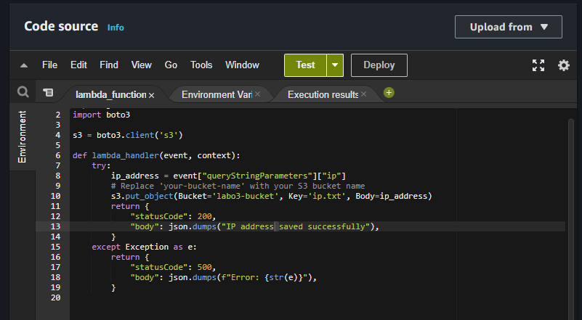
Create this python script and run it on an EC2 instance:

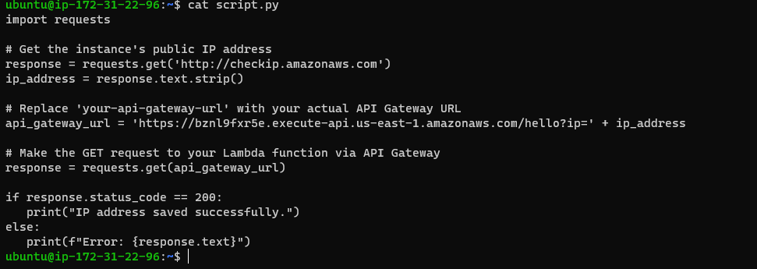
Copy file
Add an S3 bucket trigger, give it all creation events:
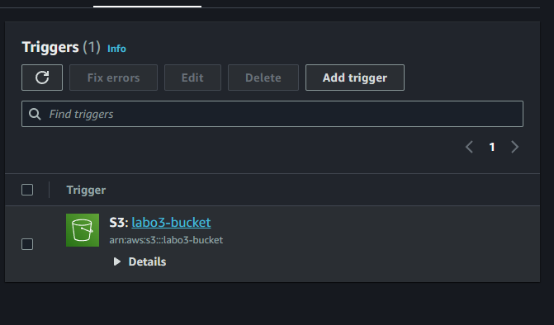
Change the python code:
